Gila Chapter
Back Country Horsemen of New Mexico|MINUTES
  - Meeting date | time 8/10/2022 6:00 PM | Meeting location Watts Hall
Meeting called by Doug Dexter  Type of meeting Monthly business meeting  Note taker Cindi deCapiteau | Attendees  Joan Bacon, Cindi deCapiteau, Dixie Dexter (via Zoom), Doug Dexter, Gerry Engel, Dave Imler, Nancy Imler, Mickey Lemon, Rawlings Lemon, Maria Longton (Zoom) Charlen Perez (Zoom), Matt Rehani (Zoom), Cheryl Roth, Diane Shriner, Jerry Shriner, George Siavalis (Zoom), Donna Tillmann, Nat Williams

Agenda topics
  - Call to order | Presenter Doug Dexter
Meeting called to order at 6:04 p.m. mountain standard time. This, Doug noted, is the chapter’s first meeting since June. In July we met at the Gomez Pavilion with GBCH members and trail volunteers and had really great potluck chow and pleasant company.
  - Additions or changes to agenda | Presenter Doug Dexter
Joan requested a minute on the agenda. Somebody suggested that we add the saga of GBCH coasters as suggested by owner of the Little Toad Creek Brewery & Distillery, Teresa Dahl-Bredine.
  - Approval of minutes | Presenter Doug Dexter
Nobody recommended changes to the agenda from the June meeting. They must have been stellar, because we know everybody reads GBCH minutes.
  - Financial & membership report | Presenter Dave Imler
Money out, money in, but more in than out.
Money out: Since June, according to Undaunted Dave Imler, the chapter expended $10,123.49 for BCHNM dues dues and insurance. We also paid our share of a matched grant ($5,000) to the Upper Gila Watershed Alliance (as reported in the minutes from March 2021), and payment for services to date for Melissa Green for $4,425.
Money in: The chapter received a $300 anonymous contribution, $1,000 from Michael and Patricia Johnson, and a modest $86,000 from New Mexico’s Trails Plus grant (issued through the NM tourism agency). The Trails Plus money is delivered up front—no completion of the work and get the grant money sometime later.
The current bank balance is over $100K. Membership remains steady at 56.
  - Public Service/Communications | Presenter Gerry Engel
Gerry reported on behalf of Melissa that she has projects going on Allie Canyon and Bear Creek. One of her trail crews packed into Little Creek and worked on that trail (map below). The Little Creek Trail #161 goes from Woody’s Corral up to Little Spring Camp, where it makes a T for McKenna Spring and Granite Peak.
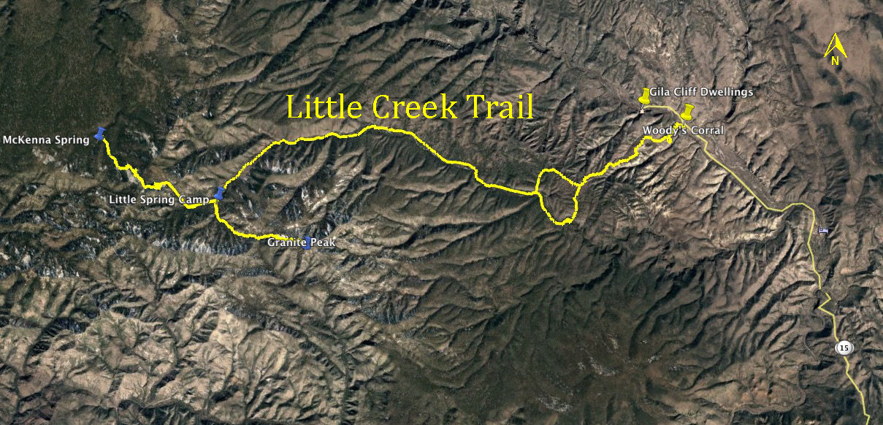
Melissa continues to work with the Forest Service to improve information coordination because it’s not always clear what the FS trail crew is doing and nobody wants to duplicate efforts. There are several projects listed for late summer/fall 2022 (view at https://www.gilabch.org/_files/ugd/867f2f_22540f07653041bebae44ec616281e72.pdf).
  - GCSAR Activity | Presenter Dave Imler
This very evening, Grant County Search and Rescue is over in the Tadpole Ridge area looking for a mushroom hunter who is overdue.
  - Summer Picnic Comments | Presenter All participants
Gerry commented that the picnic was a good thing and the chapter needs to do more of that type of thing.
Gerry commented that the GBCH picnic (at the Gomez Peak Pavilion in July) was a good thing and the chapter needs to do more fun stuff.
  - Report from the Board | Presenter Gerry Engel
Preamble: The Gila chapter is in a good financial situation now. The $85,000 from the state can be used until the end of 2025. When the Forest Service agreement is complete for Great American Outdoors Act (https://www.doi.gov/gaoa) money, we will have $100,000, which we will have until 2025-2026 to use. We have also applied for $65,000 for Grant County projects from the Southern New Mexico Resource Advisory Committee (a.k.a. RAC), and $85,000 for projects in Catron County from the RAC (https://www.fs.usda.gov/main/gila/workingtogether/advisorycommittees). Within the RAC framework, Catron County has about $900,000 to grant and Grant County has about $223,000. Our grant proposals might not be funded at those levels, but the RAC was good to us in the pre-COVID times. If we get the RAC money, we would have until September or 2026 to use it. Melissa is under contract with GBCH, so some of the incoming funds will go to her. There’s lots of money likely to come our way this year. So where do we go from here? The GBCH board met on July 28, 2022 to begin figuring out the answers. Some people are going out on GBCH trail projects as hikers (just for fun) and we need to keep afloat the notion that you don’t have to ride a horse (or even have one) to work on trails.
The board discussed the following specific matters:
Growth and efficiency of the chapter:
- We are growing and need to continue to do so to perpetuate the use of equids on public lands.
- We need to stay small enough so we have time to be out on the trails instead of in the office, bogged down with paperwork.
- We need to be efficient and make sensible use of the funds at our disposal.
- We need to proceed slowly with these matters.
Employees vs. contractors:
- The chapter’s governing documents prohibit the hiring of employees (see July 2021 Bylaws, ARTICLE V – OFFICERS AND THEIR DUTIES).
- We work during parts of the year, which further complicates hiring employees.
- Our needs point to entering into contracts with individuals or groups to avoid the costs and administrative burdens of paid employees.
- Nobody from GBCH expressed interest in contracting with us for these services. As a result, the board will explore contracting with two “youngsters” who Melissa endorses for their technical experience, flexible work schedules, and eagerness for this work.
- Contractors will help with technical trail preparation in advance of projects—making sure the trail is clear to the trail workers’ campsite.
Volunteers (not necessarily GBCH members):
- We want to continue working with volunteers and to explore ways to work with additional people.
- Everybody who works on GBCH trail projects is covered under our volunteer agreement with the Forest Service.
- We can also enter into contracts with other volunteer groups, who also provide volunteers, for which we set up and lead trail projects, cut the big logs while hiker volunteers complete tread work, brushing, and removal of small logs.
Outfitters:
- The Forest Service likes the intent of having Gila region outfitters pack in our trail crews, but limits us to working with three Gila region outfitters.
- We have a notion to meet with the outfitters annually to find out what they need to work with us by packing us in so we can help them by clearing trails they use.
- We want to continue to work with the Forest Service on its outfitter program to see if we can expand that to the modest benefit of the outfitters.
- We’re considering reimbursing packers for the animals they use when packing us in. The rate under consideration is $25/day for animals that work on the trails and $10/day for those that stay in camp.
- Need to assess the GBCH members to determine if we should encourage outfitters who work with us to become GBCH members.
Publicity:
- The GBCH websites provide good publicity about trail conditions, where to find water, etc., and not just for GBCH, but for fire crews and anybody else who visits the pages.
Trail food:
- Food is a good draw for recruiting trail workers.
Siskiyou Mountain Club:
- An Oregon group, the Siskiyou Mountain Club (https://siskiyoumountainclub.org/) (SMC) is doing the same kind of work GBCH does, but pays a trail crew. We want to learn from them.
- The board agreed to send a couple of GBCH members up to Ashland, Oregon to visit with SMC operatives to discover how they are set up and how they do business. Such a visit would probably occur in December 2022 and would involve Melissa and one other GBCH mover and shaker.
- We’re considering having SMC come down here for a couple of 10-day hitches, although SMC’s travel expenses could increase the cost of a given project.
Other trail groups:
- Working with groups like the Conservation Corps and AmeriCorps, can be expensive and supervisory issues have been reported.
Woody’s Corral:
- We have talked to the state, which (more-or-less) is in charge of Woody’s Corral about refurbishing the facility (e.g., highline posts repaired).
- We have offered to assist the state with maintenance at Woody’s.
  - Miscellany | Presenter Gerry Engel
Coasters for Little Toad: Teresa Dahl-Bredine of Silver City’s Little Toad Creek Brewery and Distillery (https://www.littletoadcreek.com/) invited Cari Lemon to design a GBCH coaster for patrons of the facility. Cari and Melissa did so. The front side appears below.
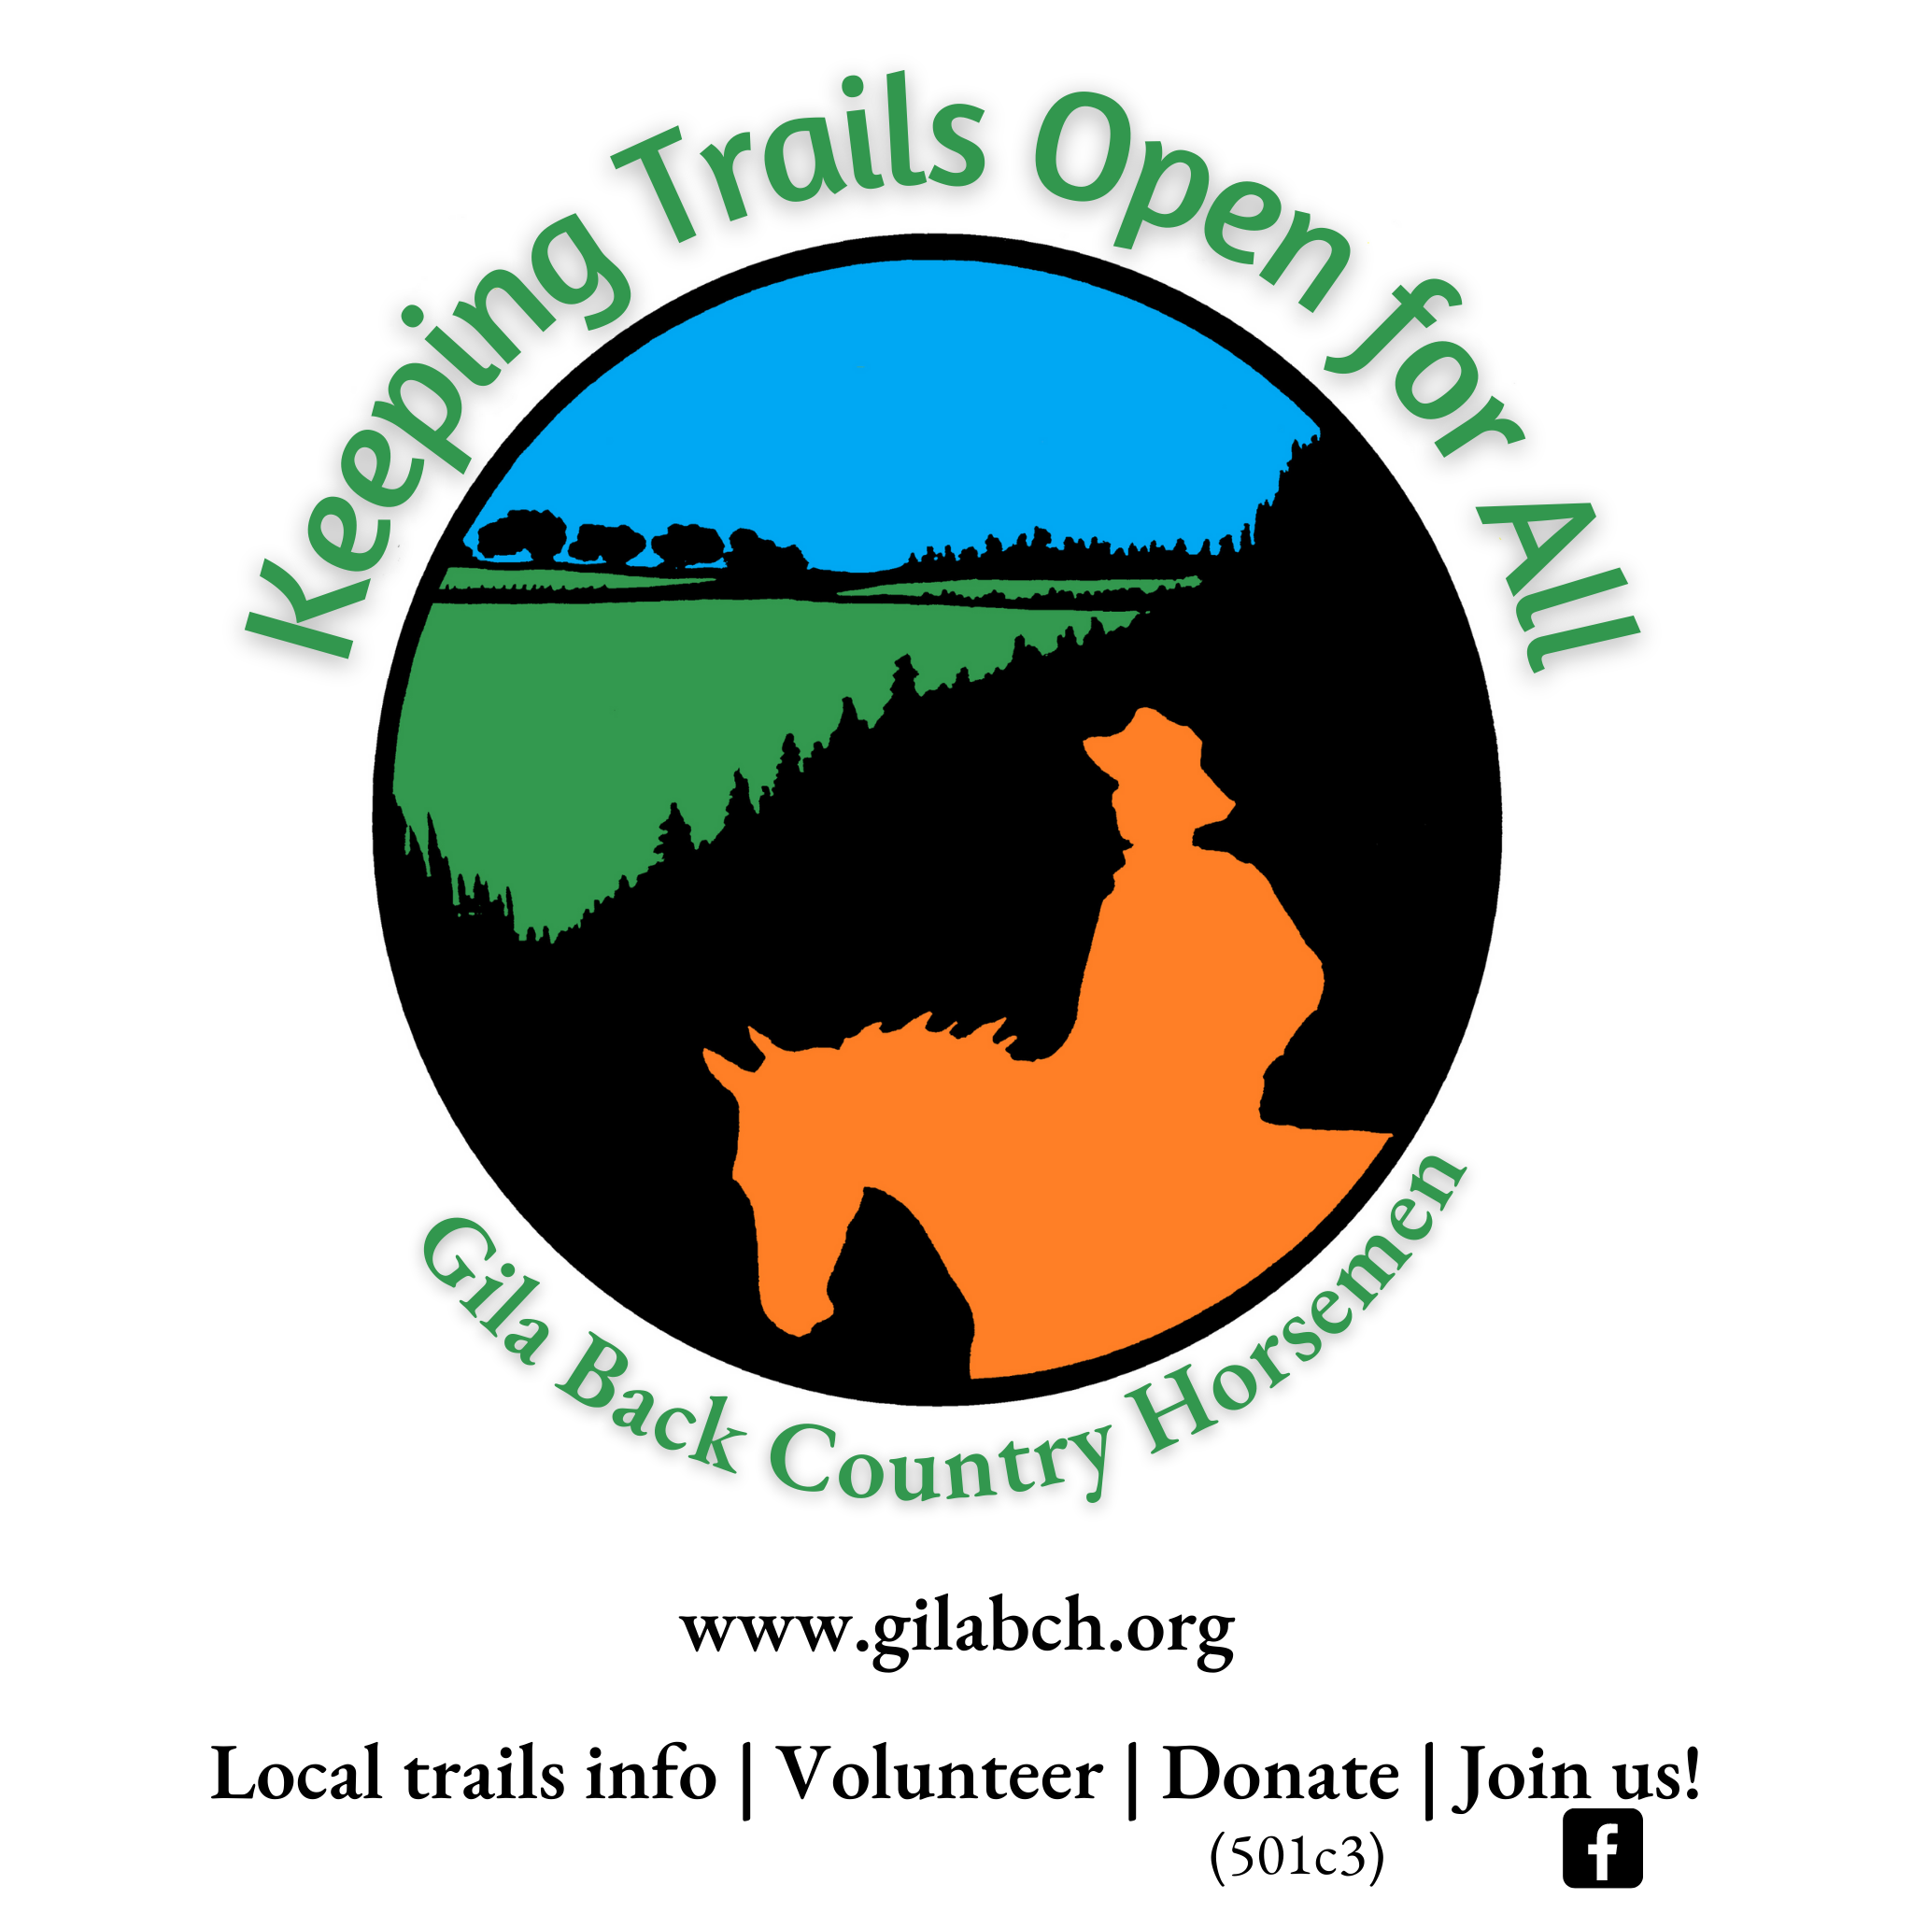
The back side (under development at this writing) will convey multi-year facts and numbers for GBCH’s accomplishments, with an eye toward building knowledge and enthusiasm for what we do.
Little Toad is planning to order a printing of 2,000 coasters. Cari will ask Teresa to print another 500 so we can pass them out to the public.
Public lands: Cheryl brought cookies to tonight’s meeting, so if you weren’t there in person, you miss out on another of Cheryl’s Betty Crocker efforts, which are always delightful.
Cheryl also reviewed comments about the July meeting of the BCHNM board of directors. The meeting featured a report from BCHNM’s public lands/legislative chair, Maresa Luzier, who summarized a meeting she attended in May with the Washington (state) Department of Fish and Wildlife.

Some questions and comments about ebikes on public lands, especially those with trails designated “non-motorized,”were these:
- Under what circumstances should ebikes be allowed on nonmotorized trails?
- Which of the three classes of ebikes should be allowed, if any? (Only class 1 should be allowed because others are too fast.)
- Concerns about ebikes used on trails or closed roads are the potential for spooking horses, traveling too fast, and danger to other trail users.
- A separate meeting on June 30 discussed the national recreational trails and about being members of it or interacting with it. There are nine recreational trails for equine use in New Mexico. The Sawmill Wagon Road in the Gila Forest north of Ft. Bayard is one of them. For GBCH, the upshot is that Gerry has seen earmarks for National Recreational Trails.
Maresa’s notes appear on page 7.
BCHNM board meeting: Joan relayed info from the recent meeting of the BCHNM board. Most northern BCHNM chapters have been badly devastated by the wildland fires of 2022. Not much BCH activity is going on up there because the fire areas are closed. Due to this unfortunate reality, the state board decided not to have a rendezvous this year.
The branding iron heater: Assuming that not everybody knows the drill yet, consider the “cookies” we help visitors make at local public events. Where we set up a log for sawyering, a cross-cut saw at hand, branding irons roasting over charcoal--then somebody from the crowd (with help from a GBCH member), slices a couple of inches off the previously mentioned log (the cookie), then uses a hot iron to char the cookie with the GBCH chapter’s brand. Enthusiastic visitors often stack up waiting for a chance to scorch a cookie because charcoal, well, it’s just not fast enough! The GBCH board recently authorized funds to purchase a propane-driven branding iron heater, which Joan happily demonstrated (except not with live fire).
The Christmas party: Nobody at tonight’s meeting could think of a better place for our Christmas Party than the Buckhorn Saloon and Opera House, so Doug will assume command of taking over that facility at the appropriate time. Doug commented that before people are allowed to join the Christmas party, they must volunteer for a GBCH office.
Meeting adjourned at 7:00.

BCHNM Public Lands Report

- BCHA PLC Meeting Results from 5/18/22 E-Bike Breakout Session # 4 from the Washington Department of Fish & Wildlife

They asked attendees to respond to three questions as followed:

  - Under what circumstances, if any should e-bikes be allowed on non-motorized trails and closed roads on lands managed by DNR and WDFW?
Shared trail concerns, ADA requirements, clearly marked trail heads, trail etiquette, motors should not be allowed on non-motorized trails

  - What of the 3 classes maybe allowed if only at all?
Class 1-3 however, class 2-3 is not realistic on single track trails.

  - What opportunities, challenges, or concerns should be considered e-bike use on non- motorized trails and closed roads on land managed by DNR & WDFW?
Quantity of users, danger of spooking horses, education, directional use, co-existence, speed

II Results from the 6/30/22 Online meeting on Fundamentals of National Recreation Trails

- National Recreation Trail Designation Requirements
- Benefits of NRT Designation
  - NRT Database (1300 trails)
  - Free Signage
  - Annual Photo Contest
  - Ambassador Program
  - Better chances for Grants
- How to Become a NRT?
- Two Processes
  - Dept of Agriculture for the National Forest System
  - Dept of Interior covering other Federal lands, State, and Tribal Lands
  - Deadline November 1, 2022
- There are Nine NRT designated in New Mexico for Equestrian Use
  - Berg/Animas Trail (Farmington)
  - Climax Canyon Nature Trail (Raton, Climax Canyon Park)
  - Columbine-Twining (Taos Ski Valley, Questa)
  - Guadalupe Ridge Trail (Guadalupe NP)
  - Jicarita Peak Trail (Taos, Santa Fe)
  - Sawmill Road Trail (Gila)
  - Sierra Vista Trail (BLM Organ Mtns.)
  - South Boundary Trail #164 (Mountain Biking trail outside of Taos)
  - Winsor Trail (Santa Fe)

- From BCHA Regional Meeting

BCHA members should reach out to their Forest Service regional trail program manager to get an idea of timelines and how to become involved. Contact emails are listed in Sidebar 1. The agency recently debuted an online “dashboard” depicting current Great American Outdoors Act Legacy Restoration Fund projects throughout the nation. Check the dashboard to view what projects have been approved and are ongoing in your forest and region. Regional points of contacts for broad questions about the timing and scheduling of GAOA LRF projects are provided in Sidebar 2.

  - US Forest Service Regional Trail Program Managers

Rocky Mountain Region (R2): Chad Schneckenburger, chad.schneckenburger@usda.gov Southwestern Region (R3): Marcy DeMillion, marcella.demillion@usda.gov

  - TAKE ACTION
The agencies will soon begin to develop their list of projects for fiscal years 2024 and 2025. This represents an important opportunity for BCH chapters to compare notes with local federal land management leaders on what projects might be funded. BCHA encourages your chapter to put forth its own "priority deferred maintenance projects" for the remaining years of GAOA funding and share it with your local agency contacts.

With three funding years remaining, there should be ample time to encourage the agencies to conduct and complete any necessary environmental analysis for more complex trail relocation projects.

BCHA recommends that you start the necessary dialogue with local agency officials now. Let them know that your chapter has specific ideas for GAOA LRF funding. They already know that your chapter will be there to help with the heavy lifting. So take advantage of the GAOA funding that continues to flow. This could represent a once-in-a-lifetime opportunity for BCHA volunteers to help the agencies make significant strides toward reducing its deferred maintenance backlog.

Here are some pointers for how to approach agency personnel.
    - Contract your local federal agency trails or recreation manager and ask them to share their current list of GAOA “priority deferred maintenance projects.” At the same time, ask them if what it might take to include in the list deferred maintenance projects that are a priority for your BCH chapter.
    - Review the agency’s list with BCH chapter members to see if trails and trail-related facilities that are important to your chapter appear on the list.
    - If deferred maintenance projects important to your chapter are included among the agency’s list, ask your agency trails/recreation manager what you might do to elevate the priority of these projects. This could include:

      - Teaming up with other trail user groups to promote the project’s benefits to multiple
user groups and its benefits to rural economic development and tourism.
      - Offering to enter into a Cost Share Agreement with the agency for reimbursement of
fixed costs associated with your chapter’s use of gas/diesel, food, “stock days,” camping
fees (if any) and the purchase of saws, fuel/oil, hand tools, etc.
Note: BCHA’s Partnerships Committee chairman can share information about how to
effectively negotiate such agency agreements.

    - If deferred maintenance projects important to your chapter are not included among the
agency’s list:
      - Engage the agency trails/recreation manager in a dialogue to explore to what it would take to include your priority project(s) on the list in subsequent years.
      - Review their list of project selection criteria to ensure that your proposal responds to agency-developed criteria.
      - Seek the opinion of other local trail user groups, tourism and chamber of commerce and local elected officials, who might support trail work/restoration that your chapter would like to promote as GAOA Legacy Restoration Fund projects. There is strength in numbers.
      - Offer to assist your agency contact in developing letters of support from other partners and/or local governments.
      - Offer to assist your agency contact in preparing any necessary paperwork.
- Register for an Outdoor Recreation Trails+ Training Session:
The Trails+ grant remains open to applications through 2022, with the second round of announcements planned for the fall. We’ve scheduled another online training session to review the application for the remaining $4.26 million.

- Register: July 14 at 10AM
- Apply for Trails+
- Read the 2022 Trails+ program guide (Spanish and English versions available)

On March 1, Trails+ opened with $7 million in funding. This investment enables ORD to broaden the scope and ambition of the grant, with local awards of up to $99,999 and regional awards of up to
$500,000.

In June, ORD announced the first cohort of awardees, with grants totaling $2.74 million. There remains $4.26 million to be distributed this year.

Apply.

This legislation allocates money through a separate set of RAC committees called the “Secure Rural Schools Resource Advisory Committees,” pursuant to the federal Secure Rural Schools and Community Self-Determination Act.
Nat Williams’ wry comment was: “If you can’t take a chainsaw into the forest, surely you shouldn’t take ebikes into wilderness.” It seems that ADA compliance is behind the drive for ebikes.
So is the Wood Haul Wagon Road Trail #55, also in the Gila Forest north of Ft. Bayard.

